
Our changing world | Year 6 | Unit 3
Assessment task — Explaining changes to the surface of Earth: Model response
Part A: Tropical cyclones
- Use the graph and table and the assessment task Explaining changes to the surface of Earth: Student resource (Beaufort wind scale) to help answer the following questions.
- Tropical Cyclone Sans Nom crossed the Queensland coast near a large town on Tuesday 15 January at 6 am. What category was Tropical Cyclone Sans Nom on Tuesday 15 January?
Tropical Cyclone Sans Nom was a category 3 cyclone on Tuesday 15 January.
- What level of damage would be sustained by the community during this time? Explain your reasoning.
Student answers should indicate that the wind speeds fall in category 12 on the Beaufort wind scale.
For example: According to the Beaufort wind scale there would be widespread structural damage due to these winds and trees would be uprooted. This would mean the community would probably have power failure; houses may lose roofs or even be destroyed. Crops could be flattened.
On the coast, the air would be filled with foam and spray. The sea would be completely white with driving spray and visibility very seriously affected. Boats and ships would suffer considerable damage. The shoreline would be damaged.
- Interpret the graph to explain how the data collected before and after 15 January could be useful.
For example: The graph reading before 15 June shows that the cyclone is steadily building up intensity. This data allows people to track the changing categories of the cyclone and therefore understand how severe and damaging the winds may be.
The graph reading drops away quickly after 15 June when the cyclone crossed the coast. This rapid decline would show that the tropical cyclone was weakening and blowing out as it passes over land.
- What is a limitation of the Beaufort wind scale?
The Beaufort wind scale was originally determined for seagoing vessels. Wind strength is determined by looking at the environment, either the sea or land, to estimate what the wind strength would be and therefore doesn’t provide an accurate reading and or the crucial elements of the wind condition, such as direction, that other instruments may provide.
Winds may be influenced by the local environment and this could greatly affect the estimated compared to the actual wind speeds in a given area.
The scale finishes at 12 (118km/h) and a storm may have much stronger winds and be a lot more damaging and the scale does not provide accurate data at this end. This means that cyclones must have their own categories for classification.
- Why may extending the Beaufort wind scale be useful?
As winds can be a lot stronger than 118 km/h, extending the scale would provide more differentiation between wind strength so more accurate forecasting could be provided.
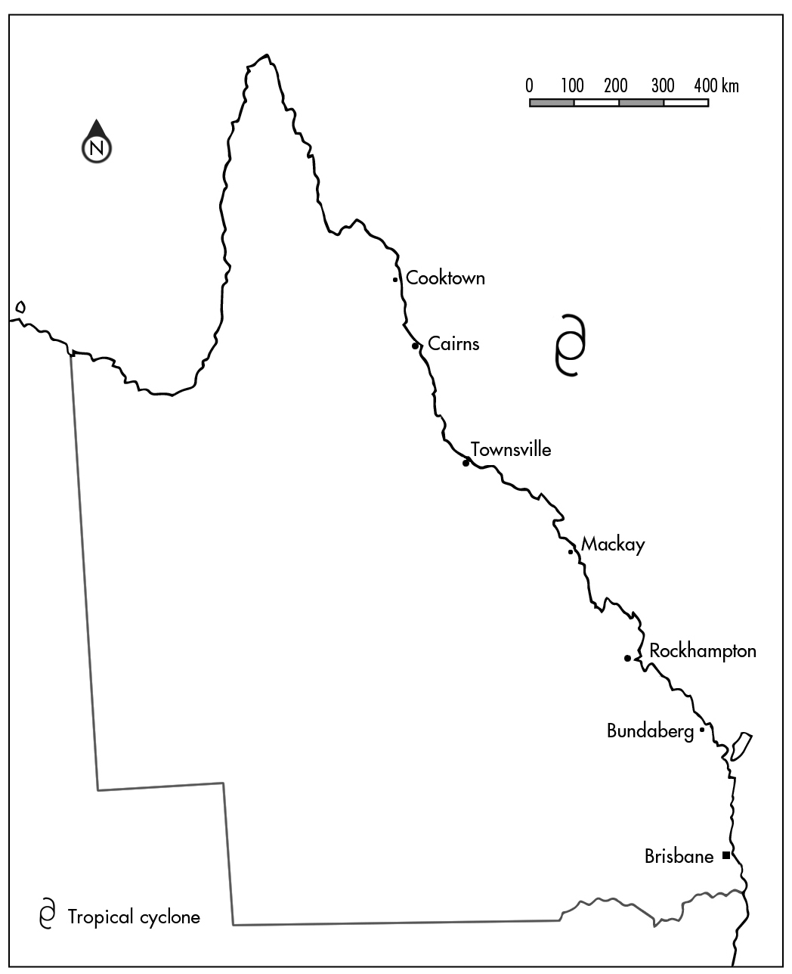
- The map below shows a tropical cyclone over the Coral Sea off the Queensland coast. After looking at the map, a friend of yours states: ‘I predict that the cyclone will cross the Queensland coast near Cairns at 11 o’clock on Tuesday morning.’
- Is this prediction accurate? Why or why not?
No, this prediction is not accurate. Predicting the path of a tropical cyclone requires more information than a single map can provide.
Students’ answers should indicate that more information will improve the prediction.
- List additional research that could be done to improve the accuracy of this prediction.
Students’ answers should indicate that additional research can improve predictions.
For example:
- tracking maps can help predict where the tropical cyclone might go in future. This would include collecting data on wind strength, speed and direction from weather instruments such as satellites and weather radars.
- historical information from previous cyclones in the area may provide an indication of what will happen based on what has typically occurred in the same area in the past.
- Justify how this additional research can be used to create a more accurate prediction.
Student answers should link a source of researched data and the benefit that this additional information would provide.
For example: Satellites and weather instruments can collect regular and current data and observations about a cyclone including wind strength, speed and direction. They provide communities and affected people with the most up-to-date information and therefore allow us to make the most accurate prediction of where the cyclone may travel.
Research has provided statistics and historical information on previous cyclones in a local area and can be very useful to predict the track of a tropical cyclone as we try and learn from the past to forecast the future. By observing and recording the behaviour of a storm we can make reasoned predictions how a similar cyclone may behave.

Part B: Coping with natural disasters
- During the course of exploring natural events you have discovered how people from across the world have developed methods to cope with different natural events.
The following passage explains a building technique used in an earthquake-prone area in northern India:
The Kashmir region in northern India experiences frequent earthquakes. The people who live in this area have developed two unique construction practices for making their houses safer during an earthquake.
These techniques, known as the Taq and Dhajji-Dewari systems, have been shown to provide earthquake-resistant qualities to buildings.
In the Taq system, large pieces of wood are used as horizontal supports embedded into the walls. These supports are located at floor level and at the top of windows. They tie together all of the elements of the building, allowing the entire structure to move during the earthquake. This prevents spreading and cracking of the brick walls.
In the Dhajji-Dewari system, timber frames for separating the brick and mortar walls into small parcels are used. The timber frames not only have vertical and horizontal supports, but also have diagonal cross beams, which divide the walls into various small panels. The most important characteristic of this type of construction is the use of lean mud mortar.
A common practice in the region is to use the Dhajji-Dewari system in the upper storey walls, especially below peaked roofs.
Reference: Indigenous knowledge for disaster risk reduction: good practices and lessons learned from experiences in the Asia- Pacific region (UNISDR) by Myers, K & Watson, P, pp 5-8. © 2008 United Nations. http://www.unisdr.org/files/3646_IndigenousKnowledgeDRR.pdf
A town on the central coast of New South Wales has recently suffered an earthquake and experienced a large amount of damage to houses that were constructed from modern-style bricks and mortar.
- Describe how the residents of the New South Wales town could use the knowledge of the Taq or Dhajji-Dewari building techniques to rebuild their houses with more earthquake-resistant designs.
Student answers should indicate that the Taq and Dhajji-Dewari building techniques would improve the modern designs. Answers should indicate that these techniques, which allow the people of northern India to suffer minimal damage during an earthquake, can be used (modified or not) to improve our own building designs.
For example: Most Australian houses are made of brick and by using the Taq system it would allow the entire building to move with the earthquake and reduce the spreading and cracking of brick walls.
The Dhajji-Dewari system could also be used on two-storey brick homes where the upper storey walls would be built in small panels to reduce the damage to the building in an earthquake.

- Explain how indigenous stories contribute to the scientific understanding of natural disasters.
Indigenous stories, including those of Aboriginal peoples and Torres Strait Islander peoples as well as the native inhabitants of Asia and the Pacific, demonstrate to scientists that geological and weather events have been occurring with some regularity in a region as the stories were recorded a long time ago.
They also give indications of the magnitude of the events in the description. Some stories also provide warnings and information about preparing for the disaster and how to avoid loss of life. These stories can be shared as a valuable source of information for disaster risk reduction.
Part C: The changing surface of Earth
4. The three sets of images below show different locations before and after an earthquake. Explain what changes have occurred to Earth’s surface because of the earthquake. Remember to include your science knowledge and scientific language in your explanation. For example:
a) | 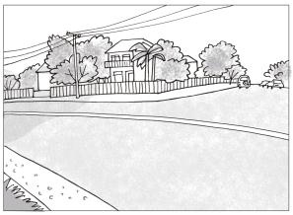 | → | 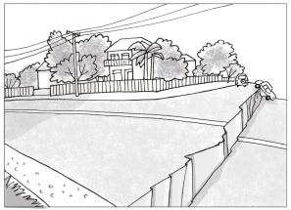
The rock in Earth’s surface has fractured at the fault. The plates have grinded against each other and one has slipped down and pulled away from each other so that the ground is no longer even. It has formed a cliff.
b) | 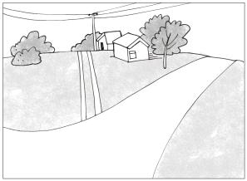 | → | 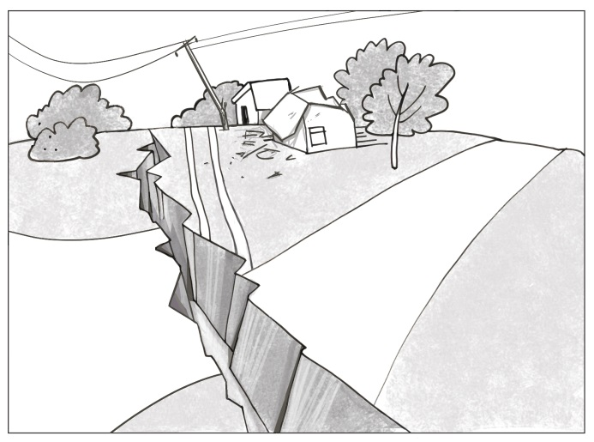
The previously flat and smooth ground now has fractured at the fault and the earth has moved horizontally. A large fissure was created and formed a valley where the two plates have settled. There is damage to buildings as there is debris on the ground. The electricity wires and pole have been damaged because of the movement of the plates.
c) | 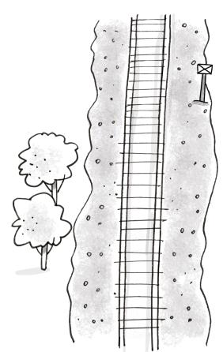 | → | 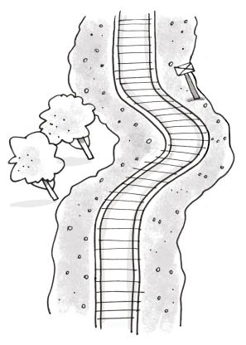
The tracks run across the fault. The plates have moved towards each other but the fault hasn’t completely ruptured. This causes the train tracks to stretch and buckle so that they no longer travel in a straight line.
- In addition to the previous images, what other sources of evidence would suggest that the changes to Earth’s surface were caused by earthquake?
Other evidence indicating an earthquake may include surface evidence that the ground may be disturbed; eyewitness statements may indicate that there was vigorous shaking; trees may have been uprooted and man-made structures damaged; and seismographic mapping and evidence.
- Refer to image C (the one with the train tracks). If a fence was placed parallel to the train tracks predict what the track would look like after the earthquake. Explain your prediction.
The fence would also be moved as the ground moves in the earthquake.
When the train tracks are bent to the left, the fence would also be shifted, stretched and bent to the left. It may even break when bent as the material the fence is made from would not be as strong as the material the tracks are made from.

